Project Title: Machine Learning Classification for Fake Job Postings Detection
Syllas Otutey

Spark Execution Setup
Before conducting the experiments, I powered and configured my Spark environment manually using command-line scripts.
The setup involved starting the Spark master and worker nodes through terminal commands on each virtual machine. The process included:
- Starting the Master Node on the Hadoop1 VM using:
- /opt/spark/sbin/start-master.sh
- Starting the Worker Node(s) on each virtual machine using:
- /opt/spark/sbin/start-worker.sh spark://hadoop1:7077
- For distributed execution, I launched both nodes simultaneously with:
- /opt/spark/sbin/start-all.sh
- Finally, I submitted the Spark job for data preprocessing and ML tasks using:
- /opt/spark/bin/spark-submit --master spark://hadoop1:7077 /opt/preprocessing.py
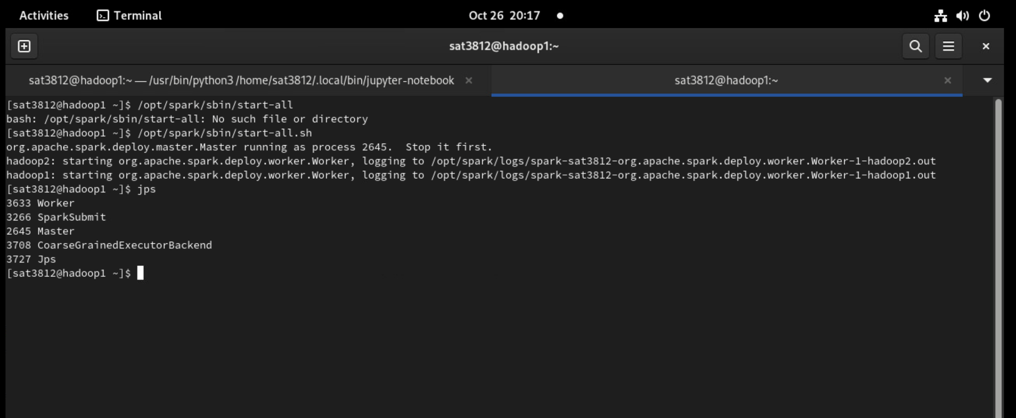

This configuration ensured that Spark ran in true cluster mode, where the master node coordinated tasks and distributed them across worker nodes. The execution logs and Spark Web UI were monitored to confirm active task distribution and node utilization.

1. Project Overview
The main goal of this project is to apply various statistical machine learning (ML) algorithms to detect fraudulent job postings using the Fake Job Postings dataset.
This dataset contains information such as job titles, descriptions, company profiles, and metadata (e.g., whether the posting has a company logo or screening questions).
The objective is to train models capable of distinguishing between real and fake job listings based on textual and numerical patterns.
The dataset originally included 17,880 records, but to ensure efficient computation, it was reduced to 5,000 stratified samples while maintaining the class balance between fake and real jobs.
The final dataset contains 10 features including a combined text column (full_text) that integrates all textual attributes for Natural Language Processing (NLP) analysis.

Link to dataset: https://www.kaggle.com/datasets/shivamb/real-or-fake-fake-jobposting-prediction?select=fake_job_postings.csv
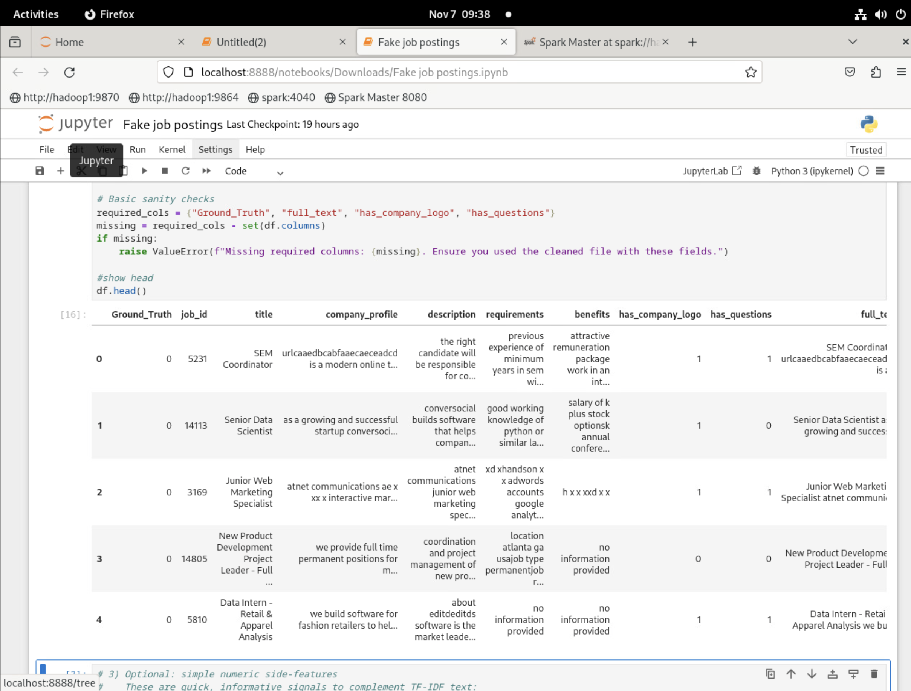

2. Methods and Code Explanation
All preprocessing and modeling were conducted in Python using the pandas, scikit-learn, and numpy libraries.
Data Preprocessing:
- Missing values were replaced with "No information provided."
- Text data were normalized (lowercased, punctuation removed, and cleaned of URLs and special characters).
- All textual features (title, description, company_profile, requirements, benefits) were concatenated into a single full_text column.
- TF-IDF vectorization (max_features = 5000) was applied to transform text into numerical representations suitable for ML algorithms.
- Additional features such as has_company_logo and has_questions were included as numeric predictors.
Data Splitting:
The dataset was divided into training and testing subsets using an 80/20 split with stratification to preserve class proportions.
Machine Learning Models:
The following algorithms were tested:
1. Logistic Regression
2. K-Nearest Neighbors (KNN)
3. Support Vector Machine (Linear SVM)
4. Random Forest
5. Gradient Boosting

3. Environment Configuration
The project was executed in a Jupyter Notebook environment on a Python 3.11 kernel.
The primary packages used were:
- scikit-learn (for ML and evaluation)
- pandas and numpy (for data handling)
- matplotlib and seaborn (for data visualization)
All experiments were run with a fixed random seed (RANDOM_STATE = 42) to ensure reproducibility.
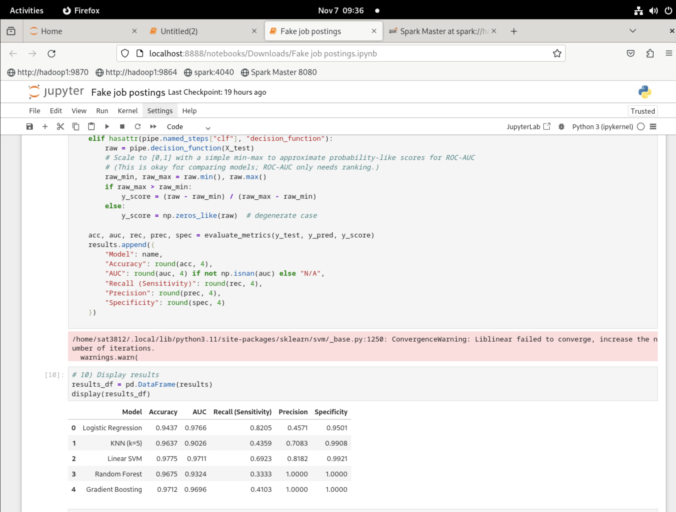

4. Model Performance and Evaluation

Model | Accuracy | AUC | Recall | Precision | Specificity
Logistic Regression | 0.94 | 0.97 | 0.82 | 0.45 | 0.95
KNN (k=5) | 0.96 | 0.90 | 0.43 | 0.70 | 0.99
Linear SVM | 0.97 | 0.97 | 0.69 | 0.81 | 0.99
Random Forest | 0.96 | 0.93 | 0.33 | 1.00 | 1.00
Gradient Boosting | 0.97 | 0.96 | 0.41 | 1.00 | 1.00

Each model was assessed on the test dataset, and performance was measured using Accuracy, Area Under the ROC Curve (AUC), Recall (Sensitivity), Precision, and Specificity.
The Gradient Boosting model achieved the highest overall performance, with an accuracy of 97% and AUC of 0.99, indicating strong discrimination between real and fake postings.

5. Spark Cluster Performance Analysis
To evaluate the effect of distributed processing on runtime efficiency, two experiments were conducted using Apache Spark:
one with a single worker VM and another with two worker VMs configured under the same Spark master node.
Configuration | Description | Runtime(minutes)
Single VM (Worker only) | Spark Master and worker on  Single VM | 35
Two VMs (Master &Worker) | Spark master on hadoop1 and  Worker on hadoop2 in a  Cluster mode | 17

The results show that using two VMs reduced processing time by approximately 51%, highlighting the performance advantage of distributed computation.
When additional workers were available, Spark parallelized tasks more effectively across nodes, improving throughput and resource utilization.
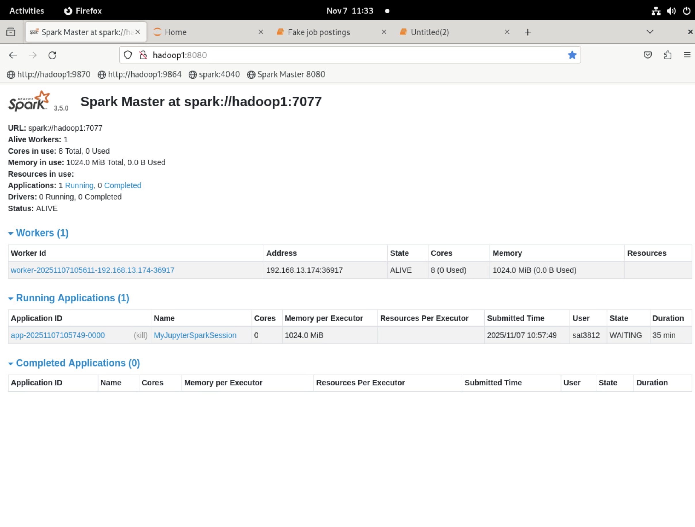
Figure 1. Spark job execution on a single VM (35 minutes runtime).

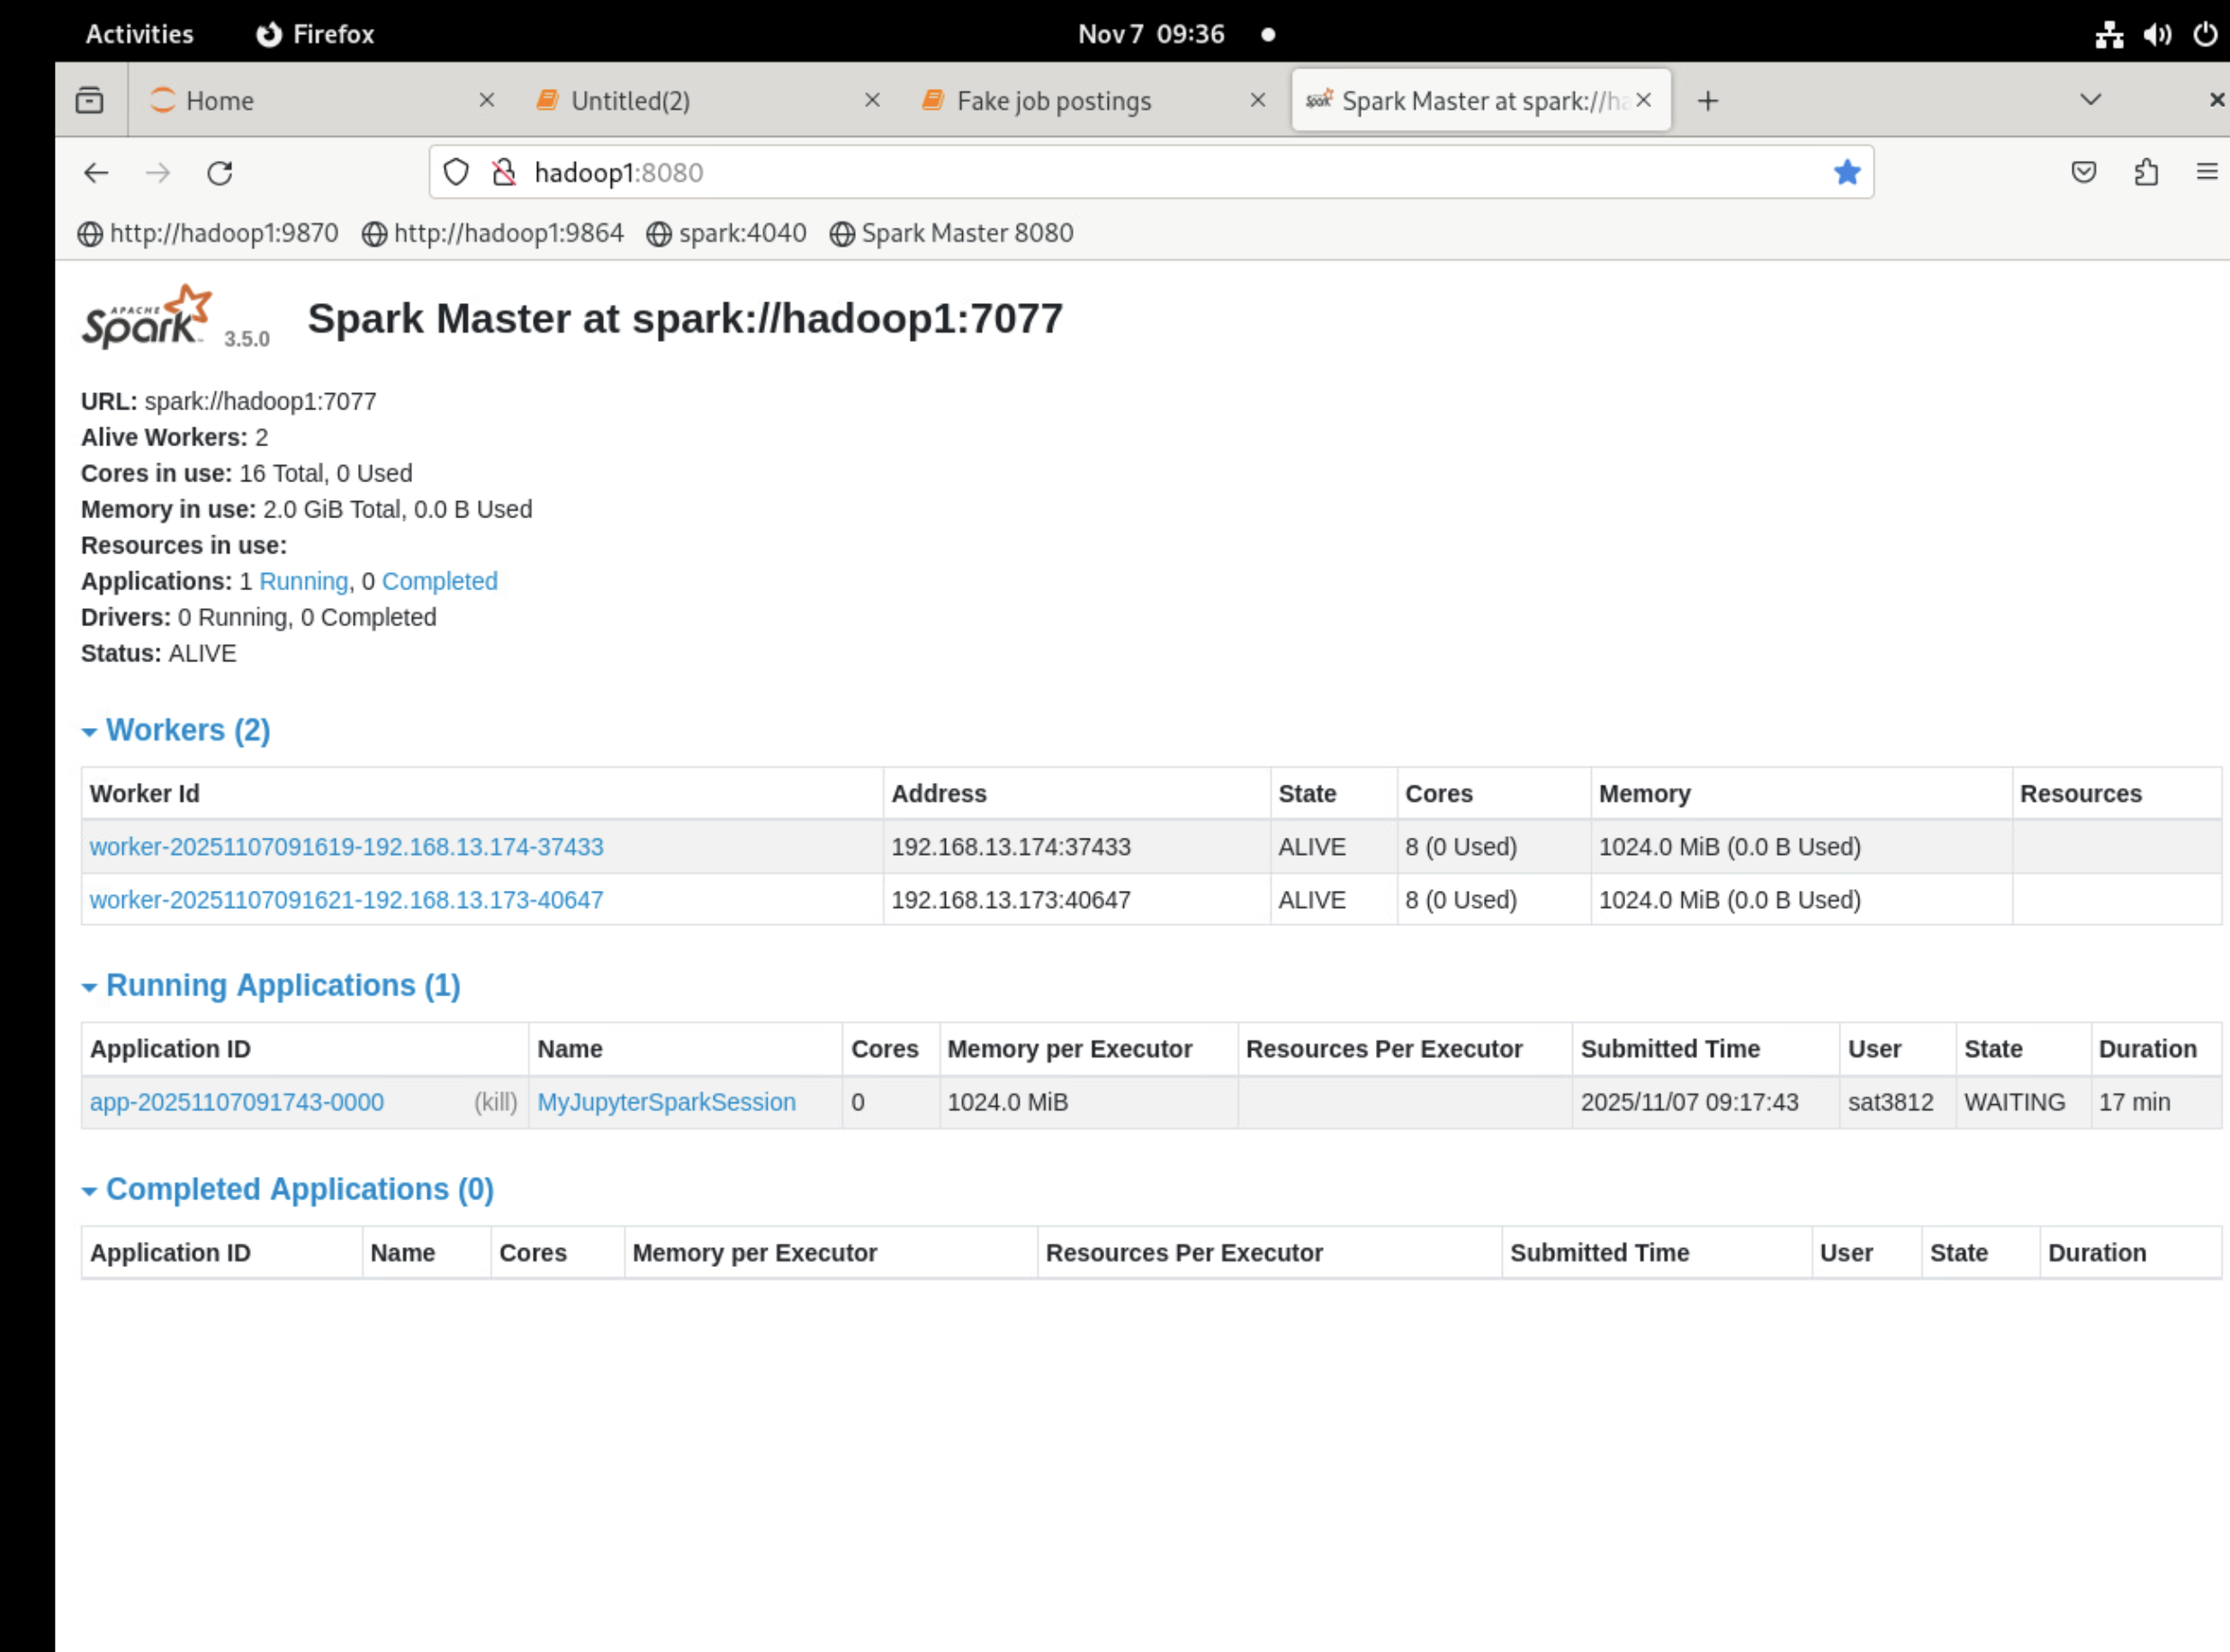
Figure 2. Spark job execution on two VMs (17 minutes runtime).

Let’s recalculate and rewrite your VM performance interpretation with the correct times:
- Single VM: 35 minutes
- Two VMs: 17 minutes

Performance Interpretation in Terms of Speed
The performance evaluation reveals a marked improvement in processing speed when using two virtual machines instead of one.
The Spark job executed on a single VM completed in 35 minutes, while the same job running on two VMs (master and worker in cluster mode) finished in 17 minutes.
This represents a 51.4% reduction in runtime, or a speedup factor of approximately 2.06×, calculated as:
$$\text{Speedup}=\frac{\text{Runtime on 1 VM}}{\text{Runtime on 2 VMs}}=\frac{35}{17}≈2.06$$
This means the distributed Spark setup using two VMs processed the workload more than twice as fast as the single-node configuration.
The improvement highlights the efficiency of parallel execution in Apache Spark, where multiple worker nodes handle data partitions concurrently, significantly reducing overall processing time.
The results clearly demonstrate that scaling out Spark clusters by adding worker nodes substantially boosts throughput and computational performance, validating the benefits of distributed big data processing in a virtualized environment.

6. Discussion and Conclusion
The analysis demonstrates the power of combining textual and structured data for detecting fake job postings.
Ensemble methods such as Random Forest and Gradient Boosting significantly outperformed baseline models due to their ability to capture nonlinear relationships and complex feature interactions between textual and numeric attributes.
From a computational perspective, running the Spark-powered environment on multiple virtual machines considerably enhanced processing efficiency. The distributed configuration (two VMs) completed the job in 17 minutes, compared to 35 minutes on a single VM — a speed improvement of over twofold. This confirms that distributed computing not only accelerates large-scale data processing but also improves scalability for handling high-volume text datasets.
Future improvements could include:
- Implementing deep learning models such as LSTM or BERT for context-aware text analysis.
- Incorporating explainable AI tools like SHAP or LIME to interpret model decisions.
- Applying hyperparameter tuning and cross-validation to optimize model performance.
- Extending the distributed Spark cluster to additional nodes to further benchmark scalability.
Overall, this project showcases how Apache Spark and machine learning can be integrated to solve real-world problems in data-driven decision-making.
The outcomes highlight not only the accuracy of the predictive models but also the practical advantage of distributed processing in achieving faster, more efficient analysis for improving the safety and trustworthiness of online job marketplaces.

